About this Document
This document is intended to be used as a supplement to the associated training video (e.g., “View Management for Lead Providers”). It contains the same steps that are described in the video but provides the information in written format for additional reference.
This document is intended for the Lead Provider audience group.

About View Management
Task: Via the View Management screen, share, make searchable, find, and schedule a view (e.g., a lead provider Pacing Report) for distribution.
As a lead provider, you can use the View Management screen to schedule a view that you have created and saved, such as a Pacing Report. Once you save the report view, it will appear from the View Management screen from where you can schedule it to be sent to an email distribution list at scheduled intervals (or simply on a defined date). In addition, you can also share a view, make a view searchable, or find views that have been created and shared by others.
Aren’t sure when to use “share”, “make searchable”, “find and add”, or “schedule”? If you:
- have created a view that you know someone will want to use, you would share the view.
- have created a view that you think may be useful but you are not sure who may need it, you would make the view searchable to allow others to find it.
- want to find views that other people have created and make searchable, use the Find and Add feature to locate these views. For instance, you are creating a complicated report you may want to check first if someone has created a view that you can leverage.
- want the system to automatically send a copy of the view to an email distribution list (or FTP server) at a designated date/time (or as a recurring event), schedule the view for export.

Using View Management as a Lead Provider
To make a view searchable:
- From the navigation menu, select View Management > View Management.
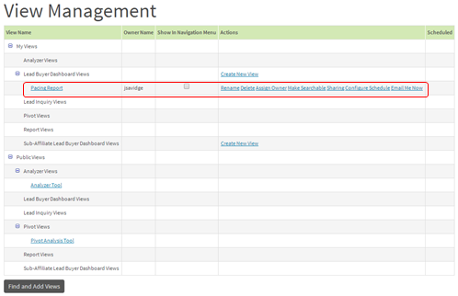
- Locate the view you want to make searchable (e.g., Pacing Report) and, from the Actions column, select Make Searchable.
- Click OK. The view becomes searchable to other users (the Make Searchable button also toggles to Make Unsearchable).
To share a view:
- Locate the view (e.g., Pacing Report) you want to share and, from the Actions column, select Sharing.
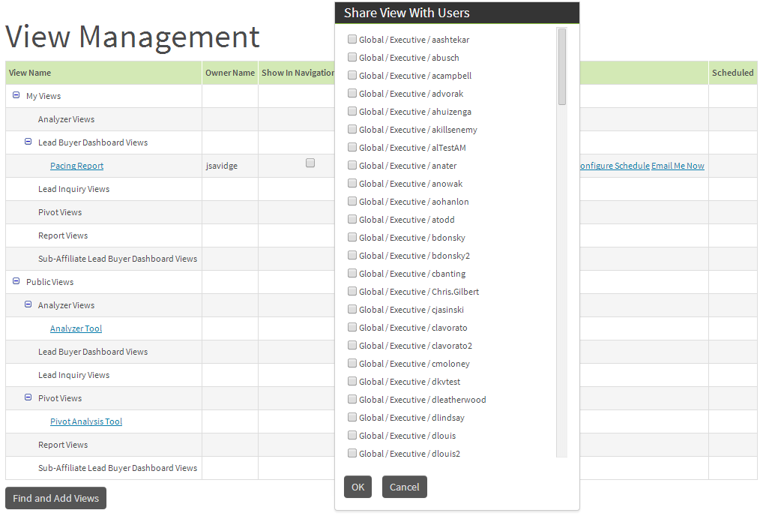
- From the dialog box, select the check box beside each user you want to share the view with and then click OK.
- Click OK. The view will appear from the other users’ View Management screen under their Public Views section.
To find a view:
- Click Find and Add Views. A dialog box is displayed, showing views shared by other users which are available for you to add to your list. If there are no views available, the message "there are no additional searchable views to select" is displayed.
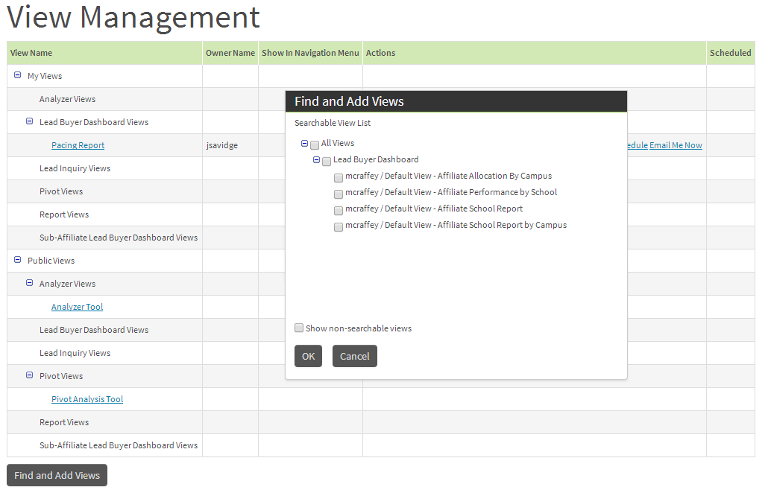
- Select the check box beside the view you want to add and then click OK.
- Click OK.
To schedule a view (e.g., Pacing Report) for distribution:
- Before scheduling the view, you must first create a distribution list in Distribution List Management:
- From the navigation menu, select Company Administration > Distribution List Management.
- Click Create New Distribution List.
- Complete the following fields and then click Save:
Field | Description
Name | Type the distribution list name.
Description | Type a brief description of the distribution list.
Email Addresses | Type the email addresses you want to include in the distribution list, separated by commas or semi colons.
- From the navigation menu, select View Management > View Management.
- Locate the view you want to schedule for export and, from the Actions column, select Configure Schedule.
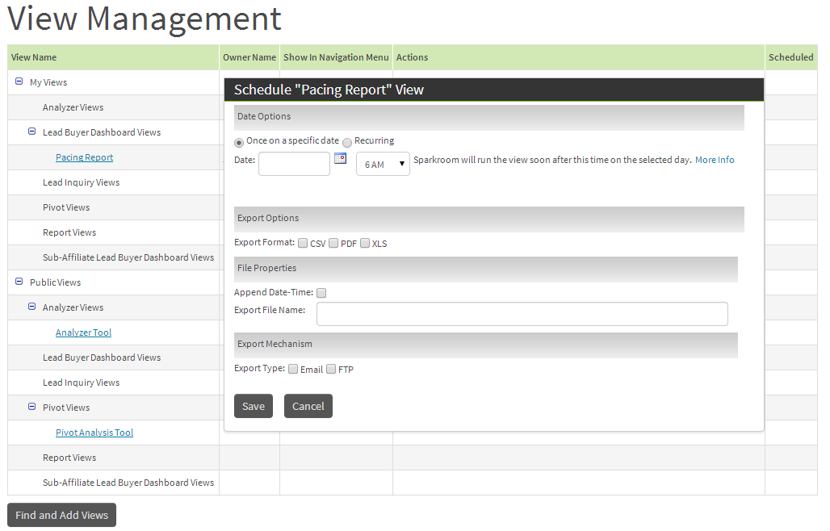
- Select one of the following options:
  - To schedule the export for a single date only, select the Once on a Specific Date radio button and then select the date from the Date field.
Or
  - To schedule a recurring export, select the Recurring radio button, complete the Hour of Day field to specify the time you want the view to be exported each day, and then select one of the following options (and complete the required information) from the Recurring Options section:
Option | Description
Every Day | Run the export every day.
Every Weekday | Run the export Monday to Friday.
Every x Day(s) | Run the export every x number of days (e.g., every two days).
Every x Weeks on Days | Run the export every x number of weeks on x day(s) during the week. For example, every second week in the month on Monday, Tuesday, and Wednesday.
Every x Day of Month | Run the export every x day of the month (e.g., every tenth day).
- To specify the export format you require, select the PDF, CSV, or XLS check box. For example, to export the view in PDF format, select PDF.
Note
If you were scheduling a lead inquiry export, the PDF format option would not be available. If you are scheduling a report, on the other hand, you will be able to select PDF as an output option.
Further, if you were scheduling a lead inquiry export, you would also have the option of selecting the columns to include in the export.
- To include the date and time in the export file, select the Append Date-Time check box.
- From the Export File Name field, type a name for the export file.
- Determine if you will export the view via email and/or FTP, as follows:
  - To export the view via email, select the Email check box.
  - (If required) Select the Email Empty Result Set check box to send the email even when the data is null.
  - From the Email File Size Limit field, type the maximum file size (in MB) that will be allowed for the email. If the email is over the size limit, it will not be sent. For example, 10 (MB).
  - (If required) From the Email Subject field, provide the email subject for the view and then provide the email body details in the Email Body field.
  - From the Distribution List field, select the distribution list that will receive the view.
And/Or
  - To export the view via FTP, select the FTP check box, complete the FTP-specific fields, and then click Test FTP Credentials to verify the FTP details provided.
- Click Save. The system will automatically email and/or FTP the view based on the schedule you have provisioned.
Congratulations, you have successfully shared, made searchable, found, and scheduled a view for distribution!
For further information on this topic please contact support@sparkroom.com.

