About this Document
This document is intended to be used as a supplement to the associated training video (e.g., “Delivery Monitor for Lead Providers”). It contains the same steps that are described in the video but provides the information in written format for additional reference.
This document is intended for the Lead Provider audience group.

About Delivery Monitor for Lead Providers
The Delivery Monitor screen allows you to search for leads which have been received by the application but not yet processed by the system (i.e., they have not been matched to the lead buyer filters). (Once a lead is processed, it can be searched from the Lead Inquiry screen, dashboard and pivot views, and is forwarded to downstream systems depending on the lead buyer's lead capture script). Commonly used search criteria are available, such as "date range" and "applicant name" as well as additional optional fields to provide a more detailed search.
Once the search is completed, the Summary Panel displays summary information (e.g., total leads captured, etc.) for all leads matching your search criteria while the Results Panel displays more granular lead information. Various details are provided for each lead including the lead provider, lead buyer, received date, result, and response code (hover your mouse over the response code to view additional details). You can filter the Results Panel based on which Summary Panel column you select; by default, the results are filtered by the Total Leads Captured column but you can also filter by Rejected to Lead Provider. Lead information displayed from this screen can be exported to CSV or XLS formats and subsequently saved, printed, sorted, and so on.
From a lead provider’s perspective, in addition to “pulling” pre-scrubbed lead data from the Delivery Monitor screen and searching by LMS ID (and other criteria), you can use the Delivery Monitor to investigate lead deliveries (to verify a lead was received by the Sparkroom application), check the response code that has been given to a lead, and view raw lead data.

Using Delivery Monitor as a Lead Provider
Task: To search for leads, investigate lead delivery, view the response code given to a lead, and view raw lead data.
- From the navigation menu, select Interfaces > Delivery Monitor. The Delivery Monitor screen is displayed.
- Complete the selection fields, as required, to determine which leads you want to view. For example, you can search by LMS ID and a date range (you can only choose a 30-day range for performance reasons).
- Click Search. The Summary Panel and the Results Panel appear: the former displays the number of inquiries matching your search criteria for each column described below, while the latter (which defaults to Captured Leads) displays detailed inquiry information filtered by the selected column.
From the Summary Panel, you can view the number of leads captured, rejected leads, resubmitted leads, and “test” leads. For each lead, the following details are provided:
Field | Description
Lead Buyer | Lead buyer who received the lead.
ID | Lead capture log ID. You can click this ID to view details about the lead capture event in order to help troubleshoot lead capture issues.
Interface | The interface which the lead was posted to.
Received Date | Date and time the lead was received by the application.
Result | Response action by the application when the lead was received (e.g., rejected).
Provider CID | The identifier for the lead provider channel.
Buyer CID | The identifier for the CUnet channel which provided the lead to the lead buyer. This applies to sub-affiliates.
LMS Reference | Primary lead ID assigned by the application.
Name | Applicant’s name provided on the lead.
Email | Applicant’s email address provided on the lead.
Campus Name | Campus name provided on the lead.
Program Name | Program name provided on the lead.
Branch Reference | Branch reference code for the campus.
Test | Indicates (using Y or N values) whether the lead was part of application testing.
Response Code | Sparkroom response code assigned to the lead.
Website | Website where the lead originated from.
CUNetwork Lead | Indicates if the lead originated from the CUnet network (Y) or not (N).
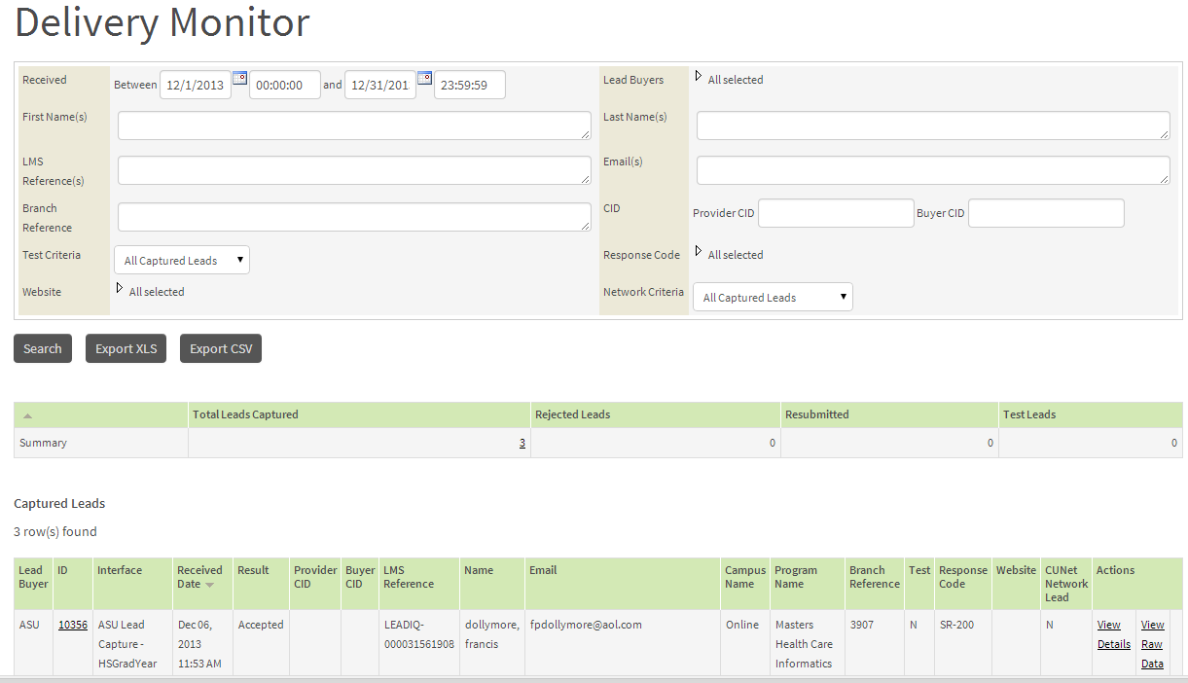
- If a lead has been given a bad response code, you can “hover” your mouse over the response code to view additional details. This is only available for “exception” response codes (i.e., additional details are not available for accepted leads).
- To view raw inquiry data, click View Raw Data. The Raw Data dialog box opens, displaying the original lead information.
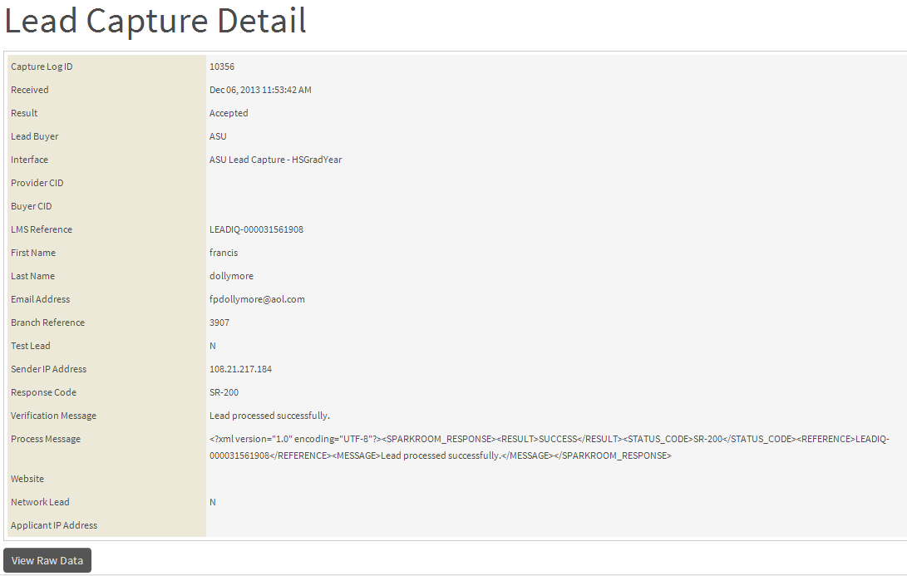
- To view additional inquiry details, click View Details. This takes you to the Lead Capture Detail screen from where you can view additional lead information or, alternately, access the raw lead data.
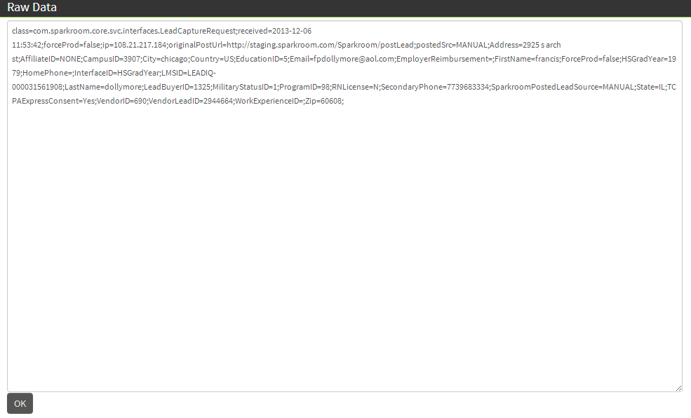
Congratulations, you have successfully searched for leads, viewed response codes given to leads, and view raw lead data!
For further information on this topic please contact support@sparkroom.com.

