Intro to Pricing Report
Lead Providers can use the Pricing Report in Sparkroom to see how their leads will be priced. You can find this under OPERATIONS->REPORTS:

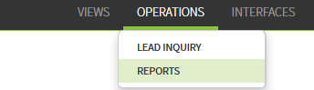

Select the Pricing Report
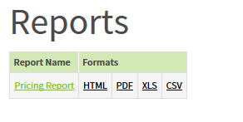
From here, you can select All Lead Buyers or specific buyers and select OK.

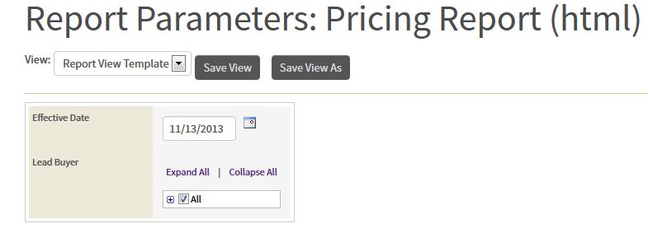
The results can be exported for your convenience:
